Adjective Complement as a Verb Complement

✅ What Is an Adjective Complement?
# Source: AI Source: Provided by: [Data Path: Persons Table -> ID Column: 1, Name_En Column: Motasem Essam] -> From: [ChatGPT] on [8/4/2025]
An adjective complement is a word, phrase, or clause that follows an adjective and completes its meaning. While it technically complements the adjective, it’s considered part of the verb complement structure when the adjective is used after a linking verb—thus indirectly completing the verb.

🔸 Structure:
# Source: AI Source: Provided by: [Data Path: Persons Table -> ID Column: 1, Name_En Column: Motasem Essam] -> From: [ChatGPT] on [8/4/2025]
- Linking Verb + Adjective + Adjective Complement
Common linking verbs: be, seem, become, feel, appear

🔸 Examples:
# Source: AI Source: Provided by: [Data Path: Persons Table -> ID Column: 1, Name_En Column: Motasem Essam] -> From: [ChatGPT] on [8/4/2025]
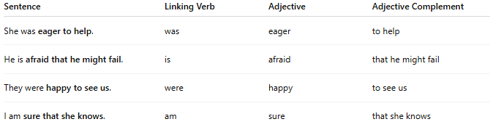
Sentence | Linking Verb | Adjective | Adjective Complement
She was eager to help. | was | eager | to help
He is afraid that he might fail. | is | afraid | that he might fail
They were happy to see us. | were | happy | to see us
I am sure that she knows. | am | sure | that she knows

🔸 Why It's a Verb Complement:
# Source: AI Source: Provided by: [Data Path: Persons Table -> ID Column: 1, Name_En Column: Motasem Essam] -> From: [ChatGPT] on [8/4/2025]
Though the adjective directly depends on the verb, the adjective complement is essential in expressing the full idea conveyed by the verb phrase. Since the verb requires the complement via the adjective, the entire structure can be considered a verb complement.
🟢 Example:
- ✅ "He is afraid that he might fail."
- ❌ "He is afraid." (grammatically fine, but less informative)

